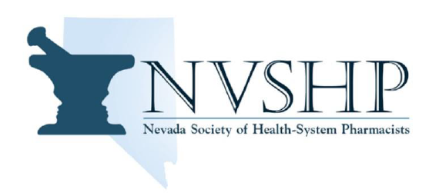
Summer 2023
The Board of Directors of NVSHP hope you all enjoyed your summers. Please see below for a quick snapshot of what your Board has been up to and member activities coming up in the next few months!

- Education
  - Northern NV Resident CE Event was held on 6/21/23 at Renown Regional Medical Center. Residents from the Renown Regional Medical Center and VA Sierra NV presented.
  - Southern NV Resident CE Event was held on 6/8/23. Residents from Dignity Health St. Rose Dominican, Valley Hospital, and VA Southern NV presented.
  - The NVSHP-NPA Annual Meeting, “Exploring the Wild West of Pharmacy,” is being held on 9/23/23.
    - 4 CEUs (including 1 hr of law) is included!
- Legislation
  - AB156 (Revises provisions relating to substance use disorders)
    - Authorizes a pharmacist to prescribe and dispense drugs for medication-assisted treatment of opioid use disorder and perform certain assessments and receive payment for services
    - Passed
  - SB352 (Revises provisions relating to prescription drugs)
    - Pharmacist payment for clinical services for hormonal contraceptives
    - Rolled into SB161 and it passed
- Public Relations
  - Follow NVSHP on social media!
    - NVSHP on Facebook
    - Instagram @NVSHP_Official
  - 2023 Research Manuscripts final submission date is 8/15/23.
    - Go to our website at nvshp.org or email us for more information.
- New Projects – “Better Left NSAID” Podcast
  - NVSHP released its first 2 episodes of the new podcast this summer!
  - New episodes will be streaming on Spotify (https://spotifyanchor-web.app.link/e/Brn2zMrlXAb)

