Rates of vancomycin associated nephrotoxicity when converting to AUC in a community hospital
Vivian Lee, PharmD
Dignity Health St. Rose Dominican Hospitals
Henderson, Nevada

Lisa Krautstrunk, PharmD, BCPS, BCIDP
Dignity Health St. Rose Dominican Hospitals
Henderson, Nevada

Brett Krautstrunk, RPh, BCPS, BCIDP
Dignity Health St. Rose Dominican Hospitals
Henderson, Nevada

Abstract:
Background
Vancomycin is the mainstay treatment for methicillin-resistant Staphylococcus aureus (MRSA) infections. Efficacious treatment is typically associated with an AUC:MIC between 400-600 mcg*h/mL. Recent studies have suggested that using a trough of 15 mg/L as a surrogate marker inaccurately estimates AUC and correlates with increased risk of nephrotoxicity. Vancomycin induced nephrotoxicity (VIN) is the development of acute kidney injury (AKI) on vancomycin therapy with no other apparent cause. The 2020 revised consensus guideline on therapeutic monitoring of vancomycin for serious MRSA infections now recommend AUC-guided dosing and monitoring as the most accurate and optimal way to manage therapy. The objective of this study aims to evaluate the safety of AUC-guided dosing as compared to trough-based dosing in relation to the rates of VIN in a community hospital setting.
Methods
This study is a retrospective chart review from December 1st, 2020 to April 31st, 2022. Patient records were identified through a Cerner report. The primary outcome was the rate of VIN. Secondary outcomes included concurrent nephrotoxic agents, length of vancomycin therapy, time to VIN, treatment modalities needed for nephrotoxicity, and survival to discharge. Inclusion criteria consisted of patients who received at least 2 doses of vancomycin therapy with a minimum of one vancomycin level drawn for trough-based dosing or two levels drawn during the same dosing interval for AUC-guided dosing according to protocol. Exclusion criteria consisted of patients < 18 years of age, those who were pregnant, had stage 5 chronic kidney disease (CKD5), in AKI, required renal replacement therapy (RRT), on vancomycin for surgical prophylaxis, received therapy < 48 hrs, or had central nervous system (CNS) infections.
Results
The study included 100 patients in the final analysis. No difference was found for the primary outcome of VIN when using AUC-guided vs. trough-based dosing (12% vs. 12%, p = 1.00). None of the secondary outcomes detected any significant differences either. The development of VIN took longer in AUC, but not significant. There was an observed mortality increase with AUC-guided dosing.
Conclusion
The incident rate of VIN showed no difference with AUC-guided versus trough-based dosing. All secondary outcomes were also similar between the dosing methods. Results were inconsistent with previous studies supporting AUC-guided dosing.
Keywords: vancomycin, nephrotoxicity, pharmacokinetics
1. Background
Vancomycin is a glycopeptide which inhibits bacterial cell wall synthesis by blocking glycopeptide polymerization through binding tightly to the D-alanyl-D-alanyl portion of the cell wall precursor.¹ Its mechanism of action makes it an effective treatment option for gram-positive infections. Vancomycin exhibits time-dependent pharmacokinetics and successful treatment is typically associated with an AUC:MIC ratio between 400-600 mcg*h/mL, which can be calculated based on Bayesian model or trapezoidal equations.² Area under the curve (AUC) is the plasma concentration of a drug versus time after dosage and provides insight to the extent of exposure to a drug and its clearance from the body, while minimum inhibitory concentration (MIC) is the lowest concentration of an antibiotic that will inhibit the growth of a given strain of bacteria.

The 2009 IDSA Vancomycin Therapeutic Guidelines previously recommended using a trough of 15 mg/L as a marker for estimating AUC:MIC > 400 if the MIC is < 1 mg/L. However, recent studies by Neely et al and Zasowski et al have suggested that trough-based dosing inaccurately estimates AUC and correlates with increased risk of nephrotoxicity, which is one of vancomycin’s most significant adverse reactions. Previously reported rates of VIN varied from 5% to 43% and usually occurs within 2-5 days of vancomycin initiation.⁶ VIN is the development of AKI on vancomycin therapy with no other apparent cause. There are various definitions for AKI, but the 2012 KDIGO Clinical Practice Guideline defines it as an increase in serum creatinine (SCr) ≥ 0.3 mg/dL over 48 hours or urine output (UOP) < 0.5 mL/kg/hr for ≥ 6 hours. Risk factors associated with VIN include vancomycin total daily dose > 4 g, concomitant nephrotoxic agents, prolonged therapy or hospital stay, the elderly population, and obesity.
AUC-guided dosing is recommended to replace trough-based dosing by the 2020 American Society of Health-System Pharmacists (ASHP), Infectious Diseases Society of America (IDSA), Pediatric Infectious Diseases of America (PIDS), and Society of Infectious Diseases Pharmacists (SIDP) guidelines on vancomycin therapeutic monitoring for serious methicillin-resistant Staphylococcus aureus (MRSA) infections due to a potential decreased risk of nephrotoxicity when compared to trough-based dosing. The pharmacy driven Vancomycin Dosing & Monitoring Protocol at Dignity Health St. Rose Dominican currently uses AUC-guided dosing based on the updated guideline recommendations. This study intended to retrospectively review patient charts to compare the safety endpoint of nephrotoxicity between patients who were on AUC-guided versus trough-based dosing.
2. Methods
A retrospective chart review was conducted from December 1st, 2020 to April 31st, 2022 at Dignity Health – St. Rose Dominican Siena campus.
2.1 Data Collection
A Cerner report was generated for patients receiving vancomycin with trough or AUC levels in the medical ICU and IMC units. Electronic health records were then searched for patients meeting other inclusion or exclusion criteria. Eligible patients were those who received at least 2 doses of vancomycin therapy with a minimum of one vancomycin level drawn for trough-based dosing or two levels drawn during the same dosing interval for AUC-guided dosing according to protocol. Patients were excluded if they were < 18 years of age, pregnant, had CKD5, in AKI, required RRT, on vancomycin for surgical prophylaxis, received therapy < 48 hrs, or had CNS infections.
The primary outcome was the rate of VIN with AKI defined per KDIGO guidelines. Secondary outcomes included concurrent nephrotoxic agents, length of vancomycin therapy, time to VIN, treatment modalities needed for nephrotoxicity, and survival to discharge.
2.2 Data Analysis
Parametric values were compared using two-sided T-test. Nonparametric values were compared using Fisher’s Exact or Chi-Square tests as appropriate. Previously reported rates of VIN varied from 5% to 43%. Based on a VIN rate of 24%, 49 patients in each treatment group were required to detect a 9% reduction with 80% power at a two-sided alpha level of 0.05. Data collected was analyzed using SPSS software v.28.
3. Results
100 patients meeting the inclusion criteria were found and included in the following analysis. Baseline characteristics are listed in Table 1 and were similar between groups for the most part. However, there were significant differences in the average length of stay being longer in the AUC group (19.1 days vs. 14.2 days, p = 0.04) and the average total daily dose being higher in the trough group (1905 mg vs. 2320 mg, p = 0.02). Table 2 included baseline characteristics specifically for patients who developed VIN in each group. P-values were not generated since the number of VIN events were a small number (n = 6 vs. n = 6). However, there was an observed higher weight and BMI in the AUC group, and the percentage of patients with CKD was also greater.

Table 1: Baseline Characteristics
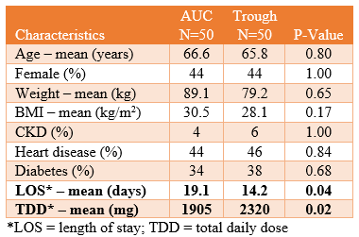
Table 2: VIN Baseline Characteristics
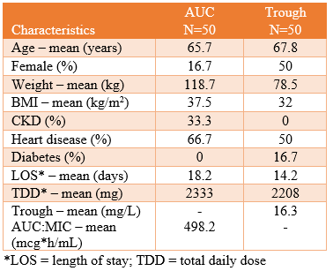
The detailed results of the primary outcome can be found in Table 3. There was no statistical difference between the AUC or trough group with regards to the rate of VIN (12% vs. 12% p = 1.00). The primary outcome was further stratified to show whether VIN was met through SCr or UOP. The secondary outcomes are summarized in Table 4. There were no significant differences found. However, there was an observed mortality increase with AUC-guided dosing.

Table 3: Primary Outcome Results
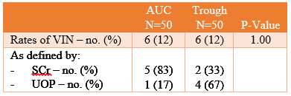
Table 4: Secondary Outcomes Results
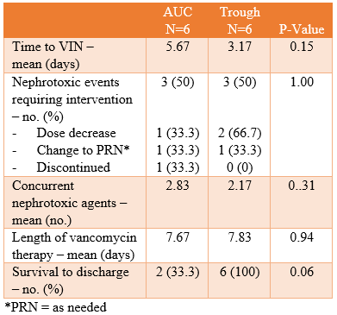
4. Discussion
From our results, there were no differences in the rate of VIN between using AUC-guided or trough-based dosing. This was not consistent with previous studies supporting AUC-guided dosing, and is likely contributed to the small sample size of this study, which is one of the study’s limitations.⁴⁻⁵ The primary outcome was stratified into meeting AKI criteria for VIN using SCr or UOP. UOP is a more precise way of indicating decline in renal function; however, this requires accurate documentation by nurses, which may not be completed at times. Additionally, not all patients had UOP monitoring. If only UOP was used to determine VIN, the number of events between AUC and trough may have been different. This is another limitation of the study.

There were no differences between cohorts with regards to the secondary outcomes. Although not statistically significant, the VIN AUC group did have additional risk factors for developing VIN than the VIN trough group, such as higher average weight, BMI, and more patients with pre-existing CKD. This could indicate that if both groups were more similar at baseline, the number of VIN events in the AUC group may have been less.
The development of VIN took longer in the AUC group, but not significant. Half of the patients in each cohort who developed VIN required some sort of intervention, with dose decrease being the most common when looking at both groups together. There was an observed mortality increase with AUC-guided dosing, but this could be contributed to the small population size or variables such as acuity level, which was collected but not stratified.
4.1 Limitations
This study does come with several other limitations. It was retrospective in nature so the results of this study can only be interpreted as an association and hypothesis generating. Additionally, there may have been selection bias because some patients had multiple trough or AUC levels within the same hospitalization; however, that was accounted for by only selecting the initial level to evaluate. Lastly, VIN as defined by UOP was determined on an every 24-hr basis, which is longer than the 6 hrs which KDIGO states is indicative of AKI. Overall, although this study shows there is no difference in the rates of VIN between AUC-guided and trough-based dosing, larger population studies are needed to confirm these initial findings.
5. Conclusion
In conclusion the incident rate of VIN showed no difference with AUC-guided versus trough-based dosing. All secondary outcomes were also similar between the dosing methods.
Conflicts of Interest
The author has no conflicts of interest to declare.
Acknowledgements
I would like to acknowledge my research preceptors who helped make this work possible. Their guidance and advice has carried me through all the stages of this project.
References
- Vancomycin (Lexi-Drugs). http://online.lexi.com/lco/action/doc/retrieve/docid/patch_f/7856. Accessed August 29, 2021.
- Farkas, J. Vancomycin pharmacokinetics: Make Vanco great again – https://emcrit.org/pulmcrit/vanco/. Accessed August 29, 2021.
- Rybak M, Lomaestro B, Rotschafer JC, et al. Therapeutic monitoring of vancomycin in adult patients: a consensus review of the American Society of Health-System Pharmacists, the Infectious Diseases Society of America, and the Society of Infectious Diseases Pharmacists. Am J Health Syst Pharm. 2009;66(1):82-98. doi:10.2146/ajhp080434
- Neely MN, Kato L, Youn G, Kraler L, Bayard D, van Guilder M, Schumitzky A, Yamada W, Jones B, Minejima E. Prospective Trial on the Use of Trough Concentration versus Area under the Curve To Determine Therapeutic Vancomycin Dosing. Antimicrob Agents Chemother. 2018 Jan 25;62(2):e02042-17. doi:10.1128/AAC.02042-17. PMID: 29203493; PMCID: PMC5786789.
- Zasowski EJ, Murray KP, Trinh TD et al. Identification of vancomycin exposure toxicity thresholds in hospitalized patients receiving intravenous vancomycin. Antimicrob Agents Chemother. 2018; 62(1):e01684-17.
- Rybak MJ, Le J, Lodise TP, Levine DP, Bradley JS, Liu C, Mueller BA, Pai MP, Wong-Beringer A, Rotschafer JC, Rodvold KA, Maples HD, Lomaestro BM. Therapeutic monitoring of vancomycin for serious methicillin-resistant Staphylococcus aureus infections: A revised consensus guideline and review by the American Society of Health-System Pharmacists, the Infectious Diseases Society of America, the Pediatric Infectious Diseases Society, and the Society of Infectious Diseases Pharmacists. Am J Health Syst Pharm. 2020 May 19;77(11):835-861. doi:10.1093/ajhp/zxaa036. PMID: 32191793.
- International Society of Nephrology. KDIGO Clinical Practice Guideline for Acute Kidney Injury. Kidney International Supplements. 2012;2(1).

