Antifungal Prophylaxis in Adults Receiving Parenteral Nutrition
Denise Truong, PharmD, BCPS
Dignity Health St. Rose Dominican Hospitals
Henderson, Nevada

Lisa Krautstrunk, PharmD, BCPS, BCIDP
Dignity Health St. Rose Dominican Hospitals
Henderson, Nevada

Stacy Henry, PharmD, BCPS
Dignity Health St. Rose Dominican Hospitals
Henderson, Nevada

Ashley Sutton, PharmD Candidate, Class of 2023
Roseman University
Henderson, Nevada

Abstract:
Introduction
Candidemia is a serious infection associated with high mortality and prolonged hospital length of stay. Antifungal prophylaxis is warranted in patients with composite risk factors including but not limited to recent intra-abdominal surgery, immunocompromised status, receiving total parenteral nutrition (TPN), having a central venous catheter, and prolonged antibiotic therapies. With a low overall reported incidence of candidemia of approximately 3% in high-risk populations, prophylaxis in general hospitalized patients is likely to be unnecessary. Inappropriate antifungal therapy is associated with higher healthcare cost and unwanted adverse events. The goal of this project is to compare the incidence rates of candidemia in non-abdominal surgical patients receiving parenteral nutrition with and without antifungal prophylaxis to determine if therapy is warranted in this patient population.
Methodology
This project was conducted from November 1, 2022 through May 1, 2023. Patients included were those admitted to Dignity Health St. Rose Dominican Hospital Siena and San Martin campuses from April 2018 – April 2023 who received at least 48 hours of antifungal prophylaxis for candidemia infection associated with parenteral nutrition. A matched control group was also generated. Exclusion criteria included those less than 18 years of age, women who were pregnant or breastfeeding, active fungal infection, multifocal fungal colonization, recent intra-abdominal surgery, or neutropenic fever.
The primary outcome was to evaluate the benefit of antifungal prophylaxis by comparing the incidence of candidemia infections. Secondary outcomes included hospital length of stay, survival at discharge, adverse events and duration of antifungal agents.
A Cerner report was collected on patients admitted to Siena and San Martin campuses from April 2018 to April 2023 who received parenteral nutrition. Chart review was conducted by the primary investigator. The data collected was analyzed using SPSS software by the primary and co-investigators.
Results
Primary outcome showed higher incidence of candidemia in the control group (1.44% vs. 0%, p = 1.0). However, the total number of positive Candida cultures from all body organ sites was higher in the prophylactic antifungal group compared to the control group (42.8% vs. 13.7%, p = 0.005). Common factors in the candidemia cases were TPN duration of 10 days and longer as well as presence of central venous catheter. On the other hand, there were no differences in hospital length of stay, all-cause mortality or medication-related adverse events between the two groups. Based on the results of this project, a defined duration of TPN > 7 days has been proposed as a criteria for initiating antifungal prophylaxis in non-abdominal surgical patients. Limitations of this study included retrospective study design, significant difference in sample sizes and more critically ill patients in the prophylactic antifungal group.
Conclusion
In summary, the results of this study showed low prevalence of candidemia in hospitalized patients as previously reported. Therefore, antifungal prophylaxis may not be warranted in general non-abdominal surgical patients receiving TPN.
Keywords: antifungal prophylaxis, parenteral nutrition
1. Background
Candidemia is a serious infection associated with high mortality and prolonged hospital length of stay. In the United States, the candidemia incidence is approximately 8.7 per 100,000 population with 96% of cases occurring during hospitalization. Central venous catheters were identified as the most prevalent risk factor, occurring in 73% of those patients.³ The NEMIS study conducted by Blumberg and colleagues reported parenteral nutrition as an independent risk factor for Candida bloodstream infections in surgical critical care patients (RR, 3.6, p < 0.001). Results showed that receiving antifungal therapy reduced the risk of candidemia (RR, 0.3).¹
A study conducted by Orsetti et al reported the prevalence of candidemia was higher in patients with recent surgery within 30 days. Furthermore, surgical patients with risk factors including older age, admission to ICU, septic shock, gastrointestinal surgery or cardiovascular surgery had higher mortality rates.⁵ Antifungal prophylaxis is warranted in this patient population, and thus excluded from this study. The overall reported incidence of candidemia is approximately 3% in high risk populations.^{2,3}
Therefore, prophylaxis in the general hospitalized patient population is likely to be unnecessary and associated with higher healthcare costs and unwanted adverse events. The goal of this study is to evaluate the incidence of candidemia infections in non-intra-abdominal surgery patients who received antifungal therapy prophylactically for parenteral nutrition.
2. Methods
This is a quality improvement evaluation on the rates of candidemia infections in patients receiving parenteral nutrition and prophylactic antifungal therapy. Retrospective chart review was conducted by the primary investigator. Informed consent was waived due to retrospective design of the study. This study was conducted from November 1, 2022 through May 1, 2023.
2.1 Data Collection
Patients included were those admitted to Dignity Health St. Rose Dominican Hospital Siena and San Martin campuses from April 2018 – April 2023 who received at least 48 hours of antifungal prophylaxis for candidemia infection associated with parenteral nutrition. A matched cohort study without prophylactic antifungal therapy was also collected. Patients excluded from the study included those less than 18 years of age, pregnant women, documented fungal infection, multifocal fungal colonization, recent intra-abdominal surgery, or neutropenic fever.
The primary outcome was to evaluate the incidence of candidemia infections. Secondary outcomes included hospital length of stay, survival at discharge, adverse events and duration of antifungal therapy.
2.2 Data Analysis
The proposed sample size to detect statistical difference (p < 0.05) for the primary outcome consists of 520 patients divided equally in each group to detect a 3% incidence of candidemia in high risk patients. The data collected was analysed using SPSS software by the primary and co-investigators.
3. Results
Of the total 283 patient charts reviewed, 153 were included in the study. Baseline characteristics were similar between the groups with the average age of 66.3 + 16.1 years, weight of 70.4 + 24 kg and 54% identifying as female. A majority of patients received broad spectrum antibiotics during their hospital admission with an average duration of 7 days. At the start of TPN therapy, 30.7% of patients were immunocompromised and 19.6% of patients were located in the ICU.
Our primary outcome showed more patients with candidemia in the control group than the antifungal prophylaxis group (1.44% versus 0%, p = 1.0) (Table 2). Of the two patients with candidemia, one patient was started on TPN approximately a month prior to admission. The blood culture and the PICC catheter tip culture grew Candida parapsilosis. Their medical history was significant for active Clostridium difficile infection and malnutrition.
The other candidemia patient had TPN initiation during admission after prolonged intubation due to SAR-CoV-2 infection. Blood cultures and PICC line cultures were reported positive for growth of Candida albicans after 10 days of TPN infusion. Both patients had their PICC lines removed and were treated with micafungin.
Additional findings from the study were the positive Candida cultures beside the positive blood cultures. The overall number of positive cultures were higher in the antifungal prophylaxis group (43.8% vs. 13.7%, p = 0.005). However, documented information of previous cultures to rule out new infections versus colonization was minimal (Table 2).
Secondary outcomes were conducted to evaluate the efficacy and safety of antifungal prophylaxis. Overall, the control group had a higher survival rate at discharge (87.8% vs. 64.3%, p = 0.017) and a shorter average hospital length of stay (15.5 days vs. 19.3 days, p = 0.272). There were no significant differences in medication-related adverse events between two groups (Table 3).
4. Discussion
The emergence of multidrug-resistant Candida auris emphasizes the need for antifungal stewardship in acute care settings. While the use of antifungal prophylaxis has been shown to reduce mortality in febrile neutropenic patients or critically ill patients with recent intra-abdominal surgeries, there is a lack of consistent data to support the routine use of prophylactic therapy in non-neutropenic or non-septic patient populations. To address this issue, guidelines from the Infectious Disease Society of America (IDSA) and the bedside Candida scoring systems from the Society of Critical Care Medicine provide resources to determine when to initiate prophylactic antifungal regimens in critically ill patients.^{6,7,8} While total parenteral nutrition is recognized as one of the risk factors for candidemia infections in these guidelines, given the low incidence rate of candidemia in non-surgical patients, initiating antifungal prophylaxis due to parenteral nutrition and without other major risk factors would lead to overuse of these agents.
The primary outcome from this project showed the low prevalence of candidemia in hospitalized patients receiving TPN but without other risk factors such as neutropenic fever or invasive abdominal surgeries (2 of 139 patients, 1.4%). Prolonged duration of TPN and coinfection with other pathogens were common factors between the candidemia cases. On the other hand, incidence of other fungal infections seemed to be higher in the prophylactic antifungal group (13.7% vs. 42.8%, p = 0.005). Of note, regarding respiratory and urine cultures, it is indeterminate whether these were newly-acquired infections or incidental colonization findings due to minimal history of previous cultures. This information could play a key role to rule out resistance in the prophylactic antifungal group, since these patients reported positive fungal cultures while receiving antifungal agents.
In terms of secondary outcomes, higher survival at discharge in the control group was reported compared to the prophylactic antifungal group (87.8% vs. 64.3%, p = 0.017). However, patients in the prophylactic antifungal group appeared to be more critically ill with more hemodialysis patients (35.7% vs. 2.9%, p = 0.0003) and patients receiving systemic steroids for acute respiratory dysfunction and sepsis (50% vs. 20.1%, p = 0.011). On the contrary, there was no significant difference in hospital length of stay or medication-related adverse events between the two groups.
A previous study conducted by Luzzati et al compared candidemia risk between different duration of TPN and PPN (categories included 0, 1 - 3, 4 - 7, more than 7 days). They found a duration of TPN 7 days and longer strongly associated with candidemia (OR 20.09, 95% CI 3.44 - 117.52)⁹. The results from this project also reported both patients with candidemia having receiving TPN at least 10 days and longer. Combined with the data of the previously - mentioned study, the proposed criteria is to consider antifungal prophylaxis in high risk patients receiving at least 7 days of TPN.
4.1 Limitations
This project had some limitations. Firstly, the patient selection process was dependent on documenting the indication for antifungal agents. Therefore, there could be a potential number of patients who met the inclusion criteria for the project but were not included due to insufficient documentation. This led to the study not recruiting enough patients to meet power in order to detect a significant difference for the primary outcome. Secondly, drastic differences in the sample size and baseline characteristics between the groups could have also skewed our results. Lastly, APACHE scores were not consistently documented for all patients included in the study and therefore not reported. This information may have been helpful to compare the severity of critical illness between the two groups and evaluation of the secondary outcomes of the study.
5. Conclusion
In summary, there was no statistically significant difference in the incidence of candidemia between the control group and the antifungal prophylaxis group. This emphasizes the need for more stringent criteria relating to the use of antifungal prophylaxis in regards to parenteral nutrition to reduce unwarranted therapy in non-surgical patients. Further studies with larger sample sizes are needed to evaluate the benefits of this proposed criteria.
Conflicts of Interest
The author has no conflicts of interest to declare.
Acknowledgements
I would like to acknowledge my research preceptors who helped make this work possible. Their guidance and advice has carried me through all the stages of this project.

References
- Blumberg HM, Jarvis WR, Soucie JM, et al. Risk factors for candidal bloodstream infections in surgical intensive care unit patients: the NEMIS prospective multicenter study. The National Epidemiology of Mycosis Survey. Clin Infect Dis. 2001;33(2):177-186. doi:10.1086/321811
- Hermsen ED, Zapapas MK, Maiefski M, Rupp ME, Freifeld AG, Kalil AC. Validation and comparison of clinical prediction rules for invasive candidiasis in intensive care unit patients: a matched case-control study. Crit Care. 2011;15(4):R198. Published 2011 Aug 9. doi:10.1186/cc10366
- Ostrosky-Zeichner L, Sable C, Sobel J, et al. Multicenter retrospective development and validation of a clinical prediction rule for nosocomial invasive candidiasis in the intensive care setting. Eur J Clin Microbiol Infect Dis. 2007;26(4):271-276. doi:10.1007/s10096-007-0270-z
- Toda M, Williams SR, Berkow EL, et al. Population-Based Active Surveillance for Culture-Confirmed Candidemia - Four Sites, United States, 2012-2016 [published correction appears in MMWR Morb Mortal Wkly Rep. 2019 Oct 18;68(41):934]. MMWR Surveill Summ. 2019;68(8):1-15. Published 2019 Sep 27. doi:10.15585/mmwr.ss6808a1
- Orsetti E, Brescini L, Mazzanti S, et al. Characterisation of candidemia in patients with recent surgery: A 7-year experience. Mycoses. 2019;62(11):1056-1063. doi:10.1111/myc.12988
- León C, Ruiz-Santana S, Saavedra P, Almirante B, Nolla-Salas J, Alvarez-Lerma F, Garnacho-Montero J, León MA; EPCAN Study Group. A bedside scoring system ("Candida score") for early antifungal treatment in nonneutropenic critically ill patients with Candida colonization. Crit Care Med. 2006 Mar;34(3):730-7. doi: 10.1097/01.CCM.0000202208.37364.7D. PMID: 16505659.
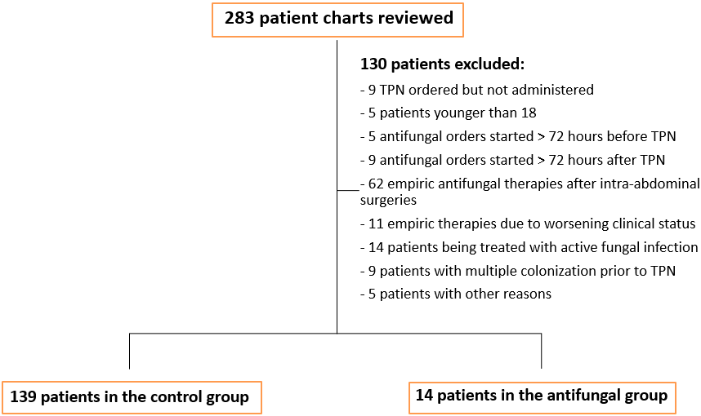
- Pappas PG, Kauffman CA, Andes DR, Clancy CJ, Marr KA, Ostrosky-Zeichner L, Reboli AC, Schuster MG, Vazquez JA, Walsh TJ, Zaoutis TE, Sobel JD. Clinical Practice Guideline for the Management of Candidiasis: 2016 Update by the Infectious Diseases Society of America. Clin Infect Dis. 2016 Feb 15;62(4):e1-50. doi: 10.1093/cid/civ933. Epub 2015 Dec 16. PMID: 26679628; PMCID: PMC4725385.
- Patterson TF, Thompson GR 3rd, Denning DW, Fishman JA, Hadley S, Herbrecht R, Kontoyiannis DP, Marr KA, Morrison VA, Nguyen MH, Segal BH, Steinbach WJ, Stevens DA, Walsh TJ, Wingard JR, Young JA, Bennett JE. Practice Guidelines for the Diagnosis and Management of Aspergillosis: 2016 Update by the Infectious Diseases Society of America. Clin Infect Dis. 2016 Aug 15;63(4):e1-e60. doi: 10.1093/cid/ciw326. Epub 2016 Jun 29. PMID: 27365388; PMCID: PMC4967602.
- Luzzati R, Cavinato S, Giangreco M, Granà G, Centonze S, Deiana ML, Biolo G, Barbone F. Peripheral and total parenteral nutrition as the strongest risk factors for nosocomial candidemia in elderly patients: a matched case-control study. Mycoses. 2013 Nov;56(6):664-71. doi: 10.1111/myc.12090. Epub 2013 May 16. PMID: 23675641.
Figure 1: Screening and selection of patients

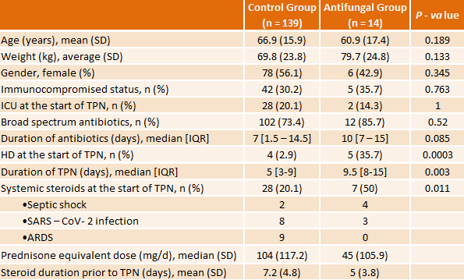
Table 1: Comparison of baseline characteristics

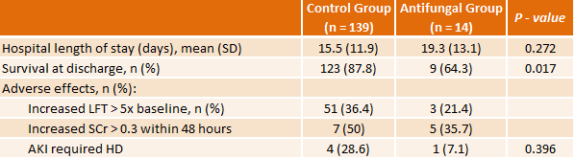
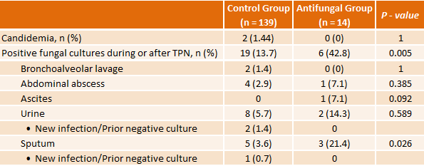
Table 3: Secondary outcomes

Table 2: Primary outcomes

