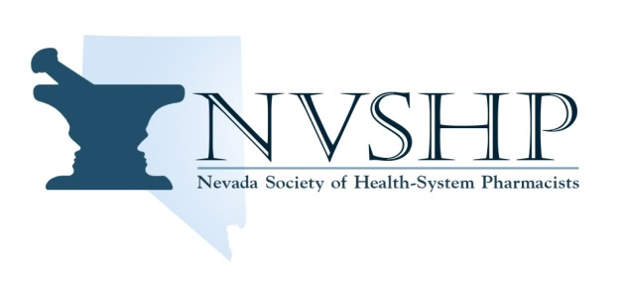

**Be Heard. Stay Connected. Create Change.**

**2022 - 2023 NVSHP Resident Representative Application Form**

**Applications will be accepted until August 31, 2022**

**Please complete the form and return by email to NVSHP at** [**nvshp@nvshp.org**](mailto:nvshp@nvshp.org)

|  |  |
| --- | --- |
| Applicants Name: | |
| NVSHP Membership Number (if not a current member you must register at [nvshp.org](https://www.nvshp.org/) by August 31, 2022): | Current Residency Position/Location (must be in the state of Nevada): |
| Email Address: | |
| Phone number: | |

***Please include (attach or email) applicant’s brief bio and a letter of intent with at least one paragraph but no more than one page stating why you would like to serve as NVSHP’s Resident Representative.***

Contact NVSHP at [nvshp@nvshp.org](mailto:nvshp@nvshp.org) with any questions.

**WWW.NVSHP.ORG**

**“To advance and support the practice of pharmacy in health-systems”**