Factors Associated with Naloxone Usage in a Community Teaching Hospital
Phil Pharmacy, PharmD
Not-a-real Hospital, Reno, NV

Bill Researcher, PharmD, BCPS, BCCCP
Not-a-real Hospital, Reno, NV

Pills McAdams, PharmD, BCPS
Not-a-real Hospital, Reno, NV
Goodstudy University, Reno, NV
Abstract:
Background
Naloxone is a reversal medication for suspected or confirmed opioid overdose. It reverses the effects of opioids, such as sedation and respiratory depression, via opioid receptor antagonism. Patients who are a higher risk of over sedation or respiratory depression should be identified so alternative agents or lower doses of opioids can be utilized to prevent naloxone utilization. Recent literature suggests there may be patterns in naloxone use based on patient-specific factors. More data is needed to further validate these factors.
Methods
This was a retrospective, observational study to assess potential factors that could lead to naloxone administration. 11,491 patients who received an opioid were reviewed for inclusion. Patients were included if they received an opioid and naloxone within 12 hours. Patients were excluded if they were in the emergency department or surgical units and if naloxone was administered within 24 hours of admission.
Results
In the six month period, 11,491 patients received at least one opioid. Of those patients, 47 patients were eligible of analysis. Statistically significant outcomes were found for increased risk of naloxone for patients 65 years of age or older, an ICD-10 coded diagnosis of heart failure, and an ICD-10 coded diagnosis of renal impairment. There was a statistically significant difference noted in route of opioid administration when comparing oral, intravenous, and transdermal routes.
Conclusion
Patients who are 65 years or older, have heart failure, and/or renal impairment are at higher risk to receive naloxone after administration of an opioid. Further research is needed to see if there is a difference in naloxone use depending on opioid route of administration.
Keywords: opioid, naloxone, risk factor
1. Background
Opioid-induced adverse effects, such as respiratory depression and altered mental status, are a significant risk for hospitalized patients. In a study published in 2014, Herzig and colleagues reviewed over a million admissions in 286 hospitals in the United States and found that 51% of patients received an opioid with 43% of those receiving multiple opioid administrations and 52% receiving opioids on the day of discharge. They reported approximately 1% having a severe opioid-related adverse effect.¹ Fortunately, naloxone is a reversal agent made specifically for these opioid-induced complications. Naloxone is an opioid antagonist that competitively blocks opioid receptors in the central nervous system (CNS). The approved routes of administration are intravenous, intramuscular, subcutaneous, and intranasal. There is also evidence to support administration via inhalation, intraosseous, and endotracheal routes. Naloxone is effective and has a relatively safe side effect profile. However, in a recent study published by Farkas and colleagues, they described an incidence of pulmonary complications, specifically non-cardiogenic pulmonary edema, after naloxone administration for opioid overdose to be about 1.1%. The mechanism of this is not well understood.²
A newly established institutional benchmark was set to keep naloxone administrations at or below 0.5% of inpatients receiving opioids. This goal necessitated a review of naloxone usage in this facility.
Recent studies have analyzed patterns of inpatient naloxone usage and have found that advanced age, obesity, heart failure, renal impairment, concurrent use of other CNS depressants, and sleep apnea have all been associated with an increased likelihood of naloxone administration during a hospital admission.^{3.4} These studies are relatively small in nature, so this study was done to see if the same pattern can be found in our institution.
2. Methods
This was a retrospective, observational study. It took place from July 1 through December 31, 2019 in a 325-bed community teaching hospital. To be included patients needed to be eighteen years of age or older and received at least one documented administration of naloxone. Exclusion criteria consisted of patients who were not administered an opioid within twelve hours prior to naloxone administration, naloxone administration in emergency department (ED), surgical, or labor and delivery (L&D) units, administration of a continuous infusion of naloxone and administration of naloxone within 24 hours of admission. The time frame of twelve hours between an opioid and naloxone was chosen due to the peak effect of most opioids occurring prior to twelve hours (to avoid confounding variables) and minimal use of extended release opioid products and methadone, which can have variable pharmacokinetics. Exclusion of patients receiving an opioid and naloxone in the ED and within 24 hours was due to the variable of patients potentially ingesting an unknown substance prior to his or her visit that could require naloxone. Exclusion of the surgical and L&D units was due to unreliable documentation and receiving naloxone to reverse analgesia after a procedure was completed.
2.1 Data Collection
Patients were identified for inclusion using a clinical surveillance software. All data was extracted from the patient’s electronic medical record (EMR). The following are the data points collected: demographic information, an ICD-10 coded diagnosis of heart failure, an ICD-10 coded diagnosis of renal impairment (using chronic kidney disease stage III and lower and/or presence of acute kidney injury), unit in the hospital, time of naloxone administration(s), a list of opioids and other CNS depressants (including time, dose, and route) administered within the twelve hours leading up to naloxone administration.
2.2 Data Analysis
The Fisher’s Exact Test was selected as all data is categorical with a small sample size. The pre-determined alpha was set at 0.05. Patients who received naloxone were compared to those who did not.
3. Results
Figure 1 shows the breakdown of the patients who were excluded and the remaining included. In the six-month period of data collection, there were 11,491 patients who received at least one documented administration of an opioid at this institution. 168 of those patients received a documented administration of naloxone. After excluding the ED, surgery, L&D units, and opioids not administered within the twelve hours leading up to the naloxone administration, 47 patients remained for analysis. The baseline characteristics are included in Table 1.

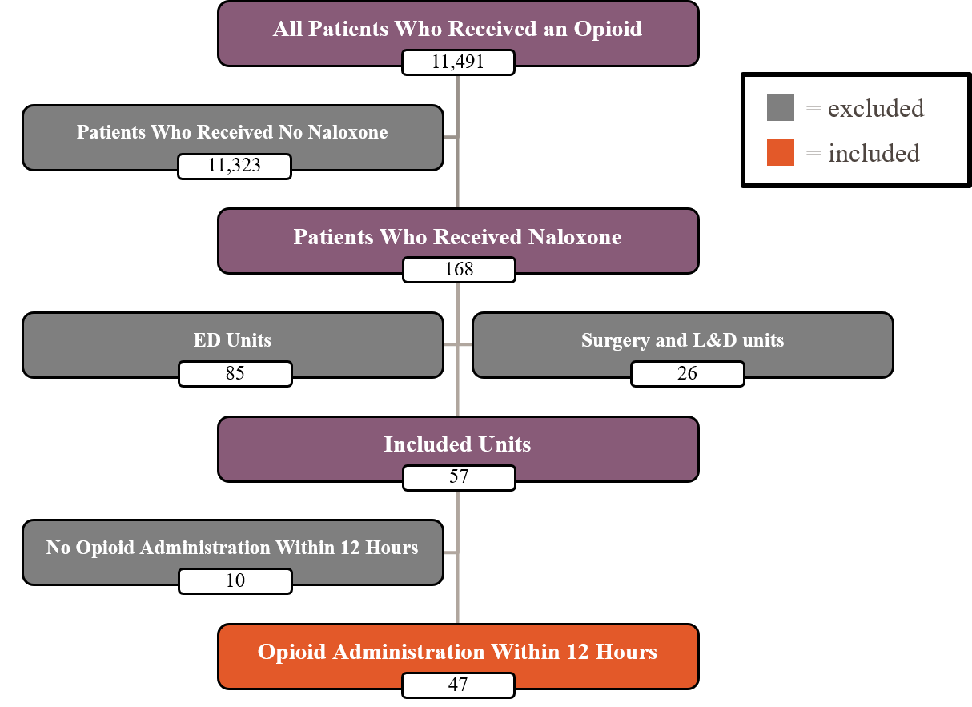
Figure 1 Flow diagram of inclusion and exclusion criteria

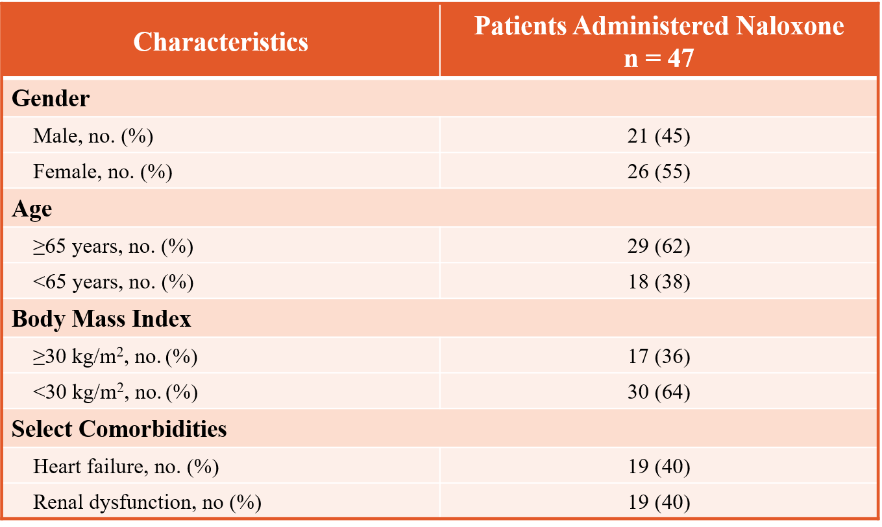
Analysis of the 47 patients yielded statistically significant outcomes for increased risk of naloxone for patients at or older than 65 years of age, an ICD-10 coded diagnosis of heart failure, and an ICD-10 coded diagnosis of renal impairment. There was also a statistically significant difference noted in route of opioid administration when comparing oral, intravenous, and transdermal routes. There was no difference noted between gender and body mass index (BMI). See Table 2 and 3 for full details.
Table 1 Baseline characteristics
4. Discussion
The results show that patients with advanced age, heart failure, and significant renal impairment have a higher risk of receiving naloxone after administration of an opioid. These results align with prior studies conducted and help to further validate this increased risk of opioid adverse effects in these patient populations.
The one exception is the difference in body mass, which has been often thought to be a risk factor. Interestingly, the study published by Vu and colleagues found that a patient’s BMI was not associated with opioid overdose and therefore naloxone administration as well.³ This could potentially be explained by using a BMI of greater than or equal to 30 which would include more patients. Other analyses could have used a higher BMI. A BMI of 30 and greater was analyzed in this study as it indicates obese status for most individuals.
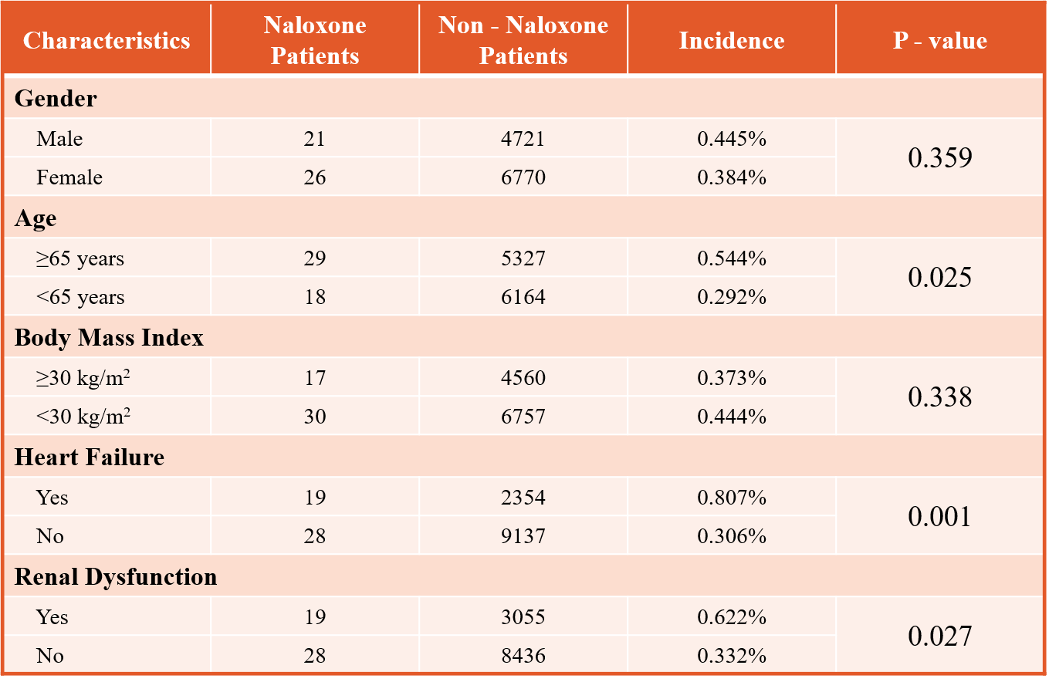
Presence of sleep apnea was not collected in this study due to poor and unreliable documentation in the patient’s chart. Concomitant use of CNS depressants including dose, time, and route was collected, but was not included in the final analysis. After review of the CNS depressants, there was no visual trend and due to time constraints a formal analysis was not conducted. However, it is a well-known fact that the interaction between benzodiazepines and opioids can potentially cause life-threatening respiratory depression. Yung and colleagues found that gabapentin may pose as a risk factor for oversedation with concomitant opioid use. In regards to the statistically significant difference of naloxone use based on opioid route of administration, this result should be taken with a grain of salt as there is a much lower incidence of transdermal opioid administration compared to oral and intravenous opioid administration. There is also the large confounding variable that these patients were likely receiving a much higher morphine milligram equivalent (MME) dose compared to patients receiving opioids from the other routes. Further investigation is needed to prove if opioid route of administration independent of MME dose is associated with increased risk of naloxone use.
Table 2 Demographic results
Table 3 Route of administration results
The main takeway of this study should be to take extra consideration when prescribing opioids to patient with advanced age, heart failure, and renal impairment. Pharmacists are in an ideal position to help assist providers when choosing what analgesia to initiate in these patients. With knowledge of drug-drug interactions, prescription drug monitoring program access, and proper transitioning between opioids, pharmacists can be an invaluable asset to help prevent patients from unnecessarily being in a situation where providers feel that naloxone administration is necessary.
4.1 Limitations
The main limitation of this study is its retrospective nature. It relies heavily on accurate documentation in the EMR and proper coding of diagnoses. The sample size of this study was small and only took place at one institution which limits its generalizability and the statistical analyses that could have been performed. However, the results mostly align with previous studies which helps its validity. Not controlling for the concurrent use of other CNS depressants also represents a significant confounding variable.
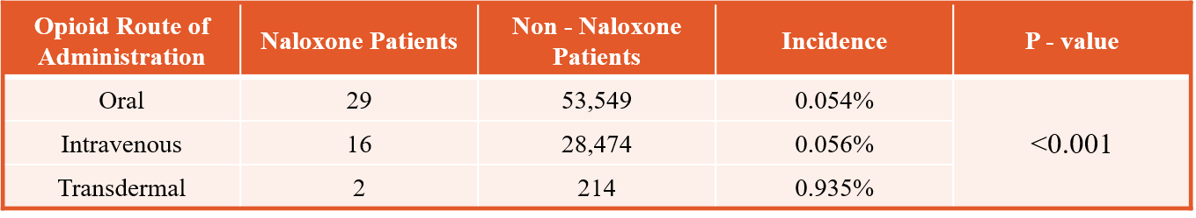
5. Conclusion
This study found that patients who are 65 years or older, have heart failure, and/or renal impairment are at higher risk to receive naloxone after administration of an opioid at this institution. Further research is needed to see if there is a difference in naloxone use depending on opioid route of administration.
Conflicts of Interest
The author declares that he has no conflicts of interest.
Acknowledgements
The author would like to give a special thanks to Pills McAdams, PharmD, BCPS and Bill Researcher, PharmD, BCPS, BCCCP for their assistance and advice on this project.
References
- Herzig SJ, Rothberg MB, Cheung M, Ngo LH, and Maracantonio ER. Opioid utilization and opioid-related adverse events in nonsurgical patients in US hospitals. J Hosp Med. 2014 Feb;9(2):73-81
- Farkas A, Lynch MJ, Westover R, et al. Pulmonary complications of opioid overdose treated with naloxone. Ann Emerg Med. 2020 Jan;75(1):39-48
- Vu Q, Beselman A, Monolakis J, Wang A, and Rastegar D. Risk factors for opioid overdose among hospitalized patients. J Clin Pharm Ther. 2018 Dec;43(6):784-9.
- Yung L, Lee KC, Hsu C, Furnish T, and Atayee RS. Patterns of naloxone use in hospitalized patients. Postgrad Med. 2017 Jan;129(1):40-5

